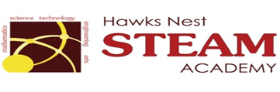School Counseling Program Newsletter
Shandrai Silva, School Counselor | January 2018

Counselor Message  Happy 2018! It’s hard to believe we are already at the beginning of another calendar year and the second half of the school year! Where did the time go?  The new year is a great time for reflection. As I reflect on and assess the school counseling program so far this school year, I hope to gain valuable feedback from each of you. Please feel free to share your thoughts. My contact information is below.  This month, the school counseling program will continue to provide classroom lessons, small group counseling and individual meetings with students. In January, we’re recognizing No Name Calling Week, National Mentoring Month and The Great Kindness Challenge.  Looking forward to a great 2018! Hope you are.  _________________________  How to see the school counselor  Classroom guidance classes are weekly based on grade level specials schedule. Small group counseling and individual counseling by self -referral, parent referral, teacher referral, administrator referral or counselor initiated.  Contact School Counselor at 704-866-8467or sosilva@gaston.k12.nc.us.  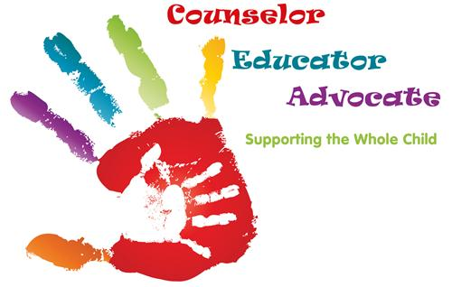 | Home of the Hawks    Kindness in Action  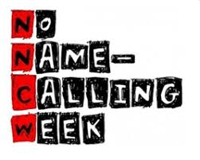  January 15th – 19th  GCS Kindness Challenge Week  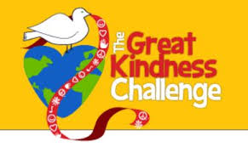  January 22 – 28, 2018  *Wear Yellow on Jan. 25th  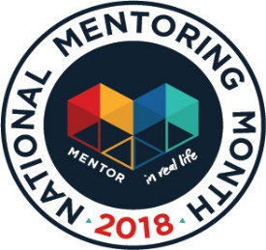 | Character Education  “We’re Soaring with Good Character”  ______________________________  The character trait of the month is Perseverance.  Perseverance means a steady will to complete a task in spite of any obstacles before you. Students will have an opportunity to learn more about perseverance through morning announcements and classroom activities  ___________________________________  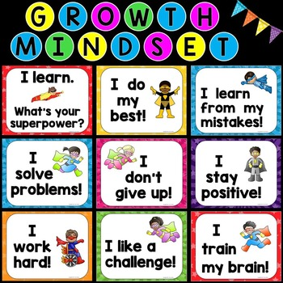  By Anne Gardner  Teachers Pay Teachers  “Intelligence plus character- that is the goal of true education.”  Dr. Martin L. King, Jr.  Foster Resilience in Students by…  - Cultivating meaningful relationships  - Modeling respect unconditionally  - Setting reasonable expectations  (Taken from 3 Rs of Resilience by Mary Ellen Knight on Teachers Pay Teachers)
Thank you, Mentors!

